Module 2: Library Management System

Submitted by: Akash Aniyeri

TO: DR.Jitha P Nair

____________________________________________________________________________________________________

***Topic: Library Management System***

Create a database named library and following TABLES in the database:

1. Branch

2. Employee

3. Books

4. Customer

5. IssueStatus

6. ReturnStatus

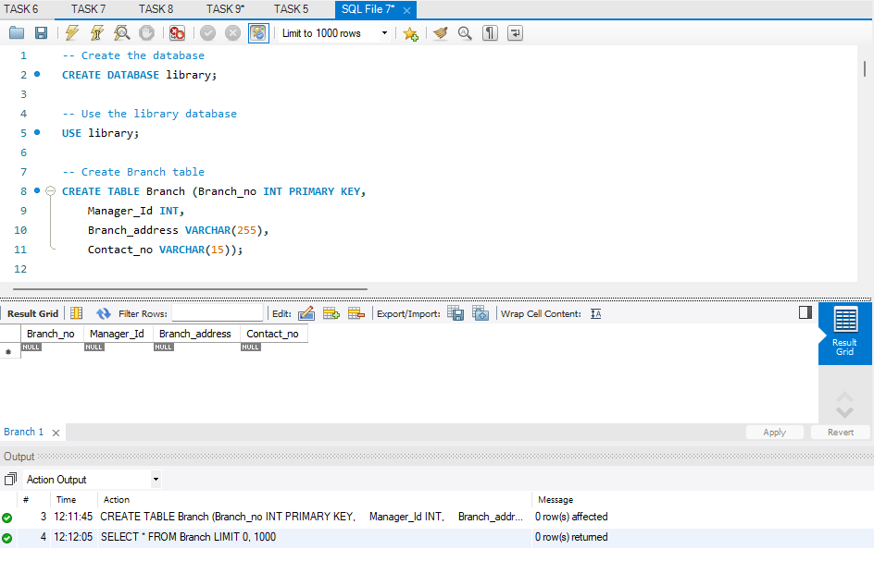

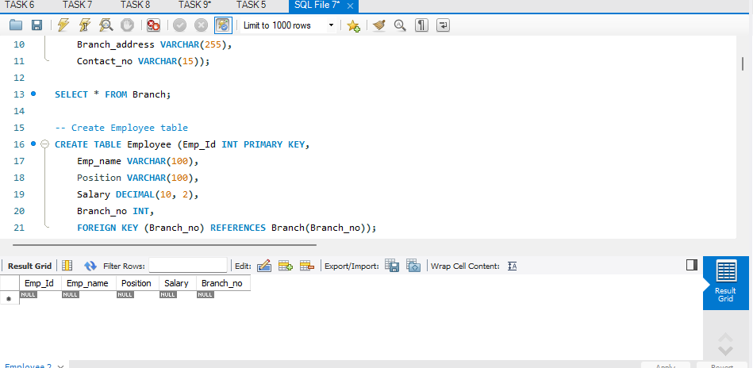

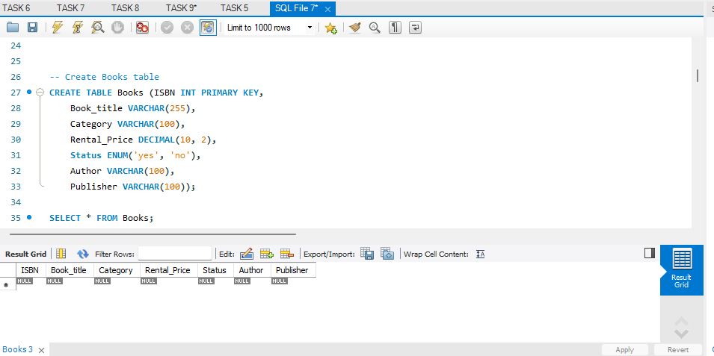

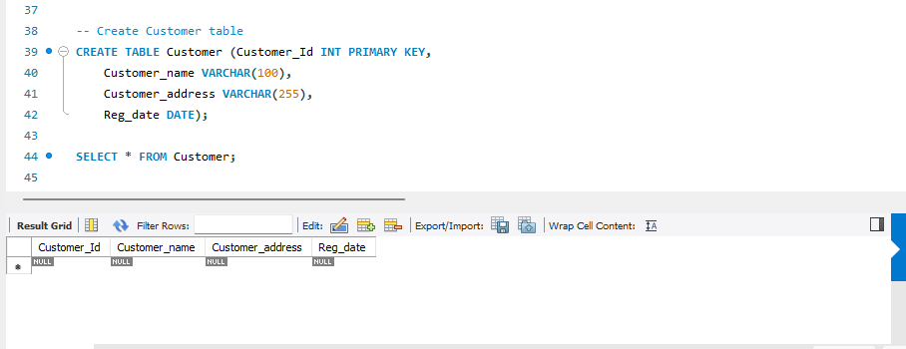

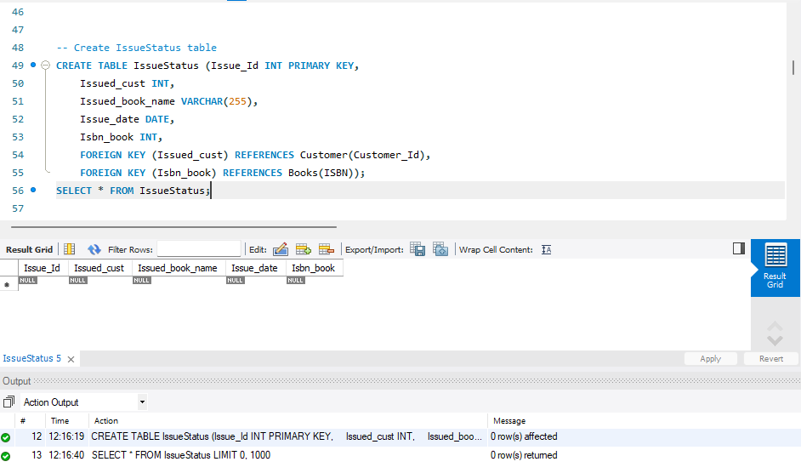

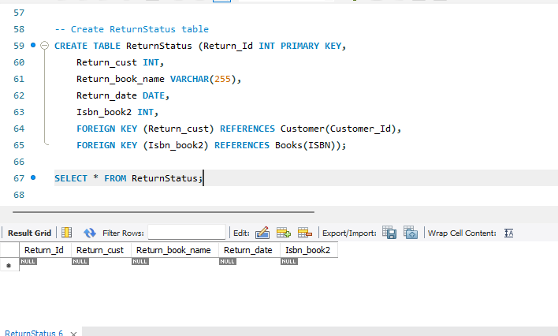

__________________________________________________________________________________

Attributes for the tables:

1. Branch

Branch_no - Set as PRIMARY KEY

Manager_Id

Branch_address

Contact_no

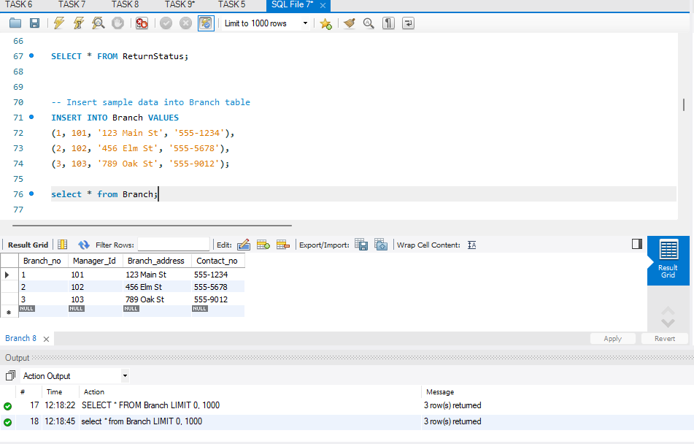

2. Employee

Emp_Id – Set as PRIMARY KEY

Emp_name

Position

Salary

Branch_no - Set as FOREIGN KEY and it refer Branch_no in Branch table

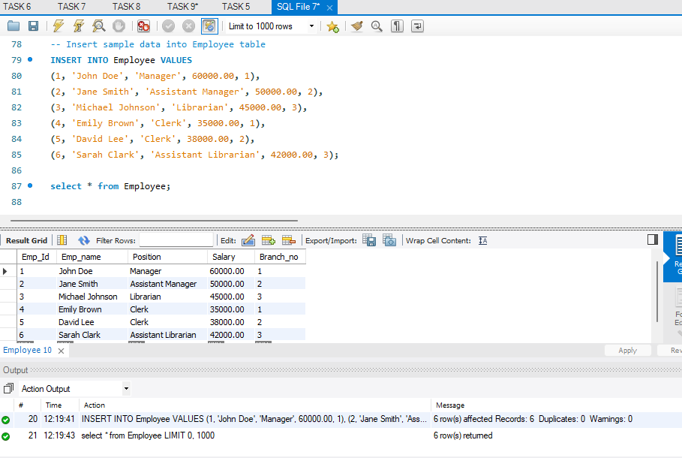

3. Books

ISBN - Set as PRIMARY KEY

Book_title

Category

Rental_Price

Status [Give yes if book available and no if book not available]

Author

Publisher

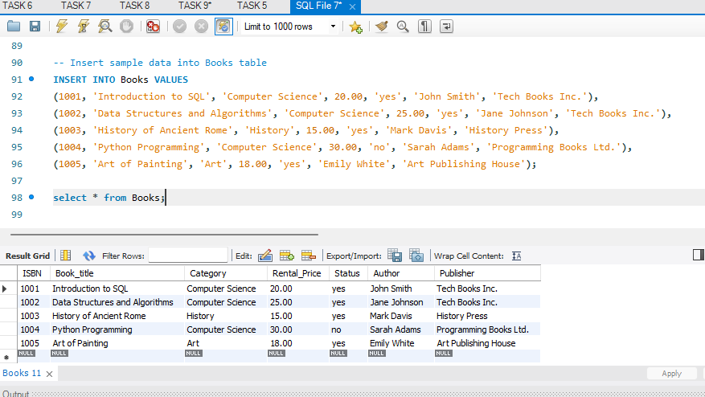

4. Customer

Customer_Id - Set as PRIMARY KEY

Customer_name

Customer_address

Reg_date

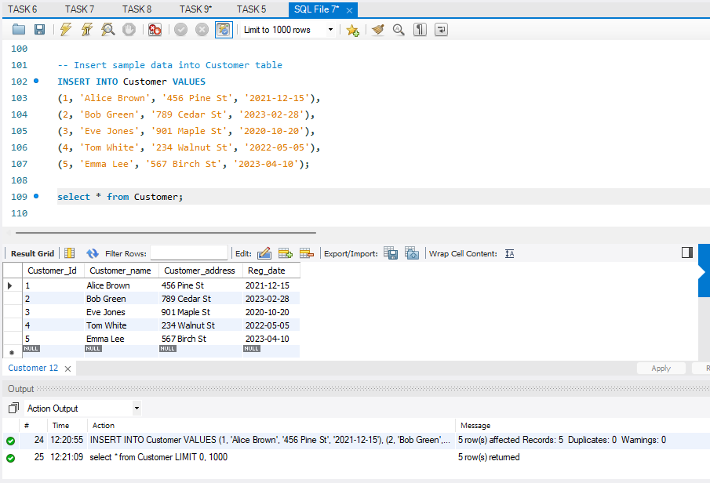

5. IssueStatus

Issue_Id - Set as PRIMARY KEY

Issued_cust – Set as FOREIGN KEY and it refer customer_id in CUSTOMER table Issued_book_name

Issue_date

Isbn_book – Set as FOREIGN KEY and it should refer isbn in BOOKS table

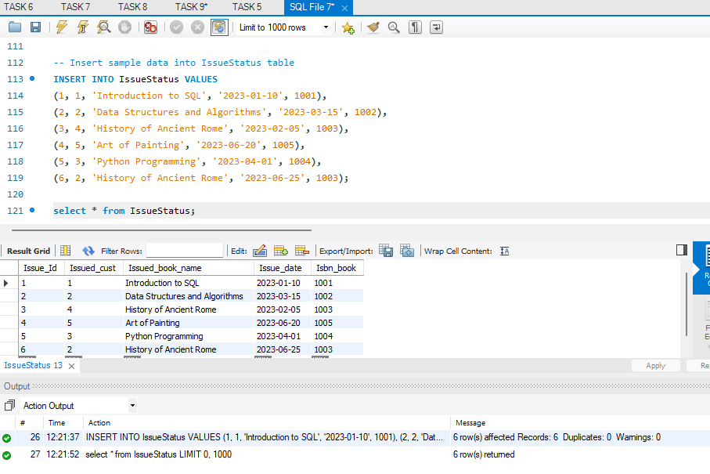

6. ReturnStatus

Return_Id - Set as PRIMARY KEY

Return_cust

Return_book_name

Return_date

Isbn_book2 - Set as FOREIGN KEY and it should refer isbn in BOOKS table

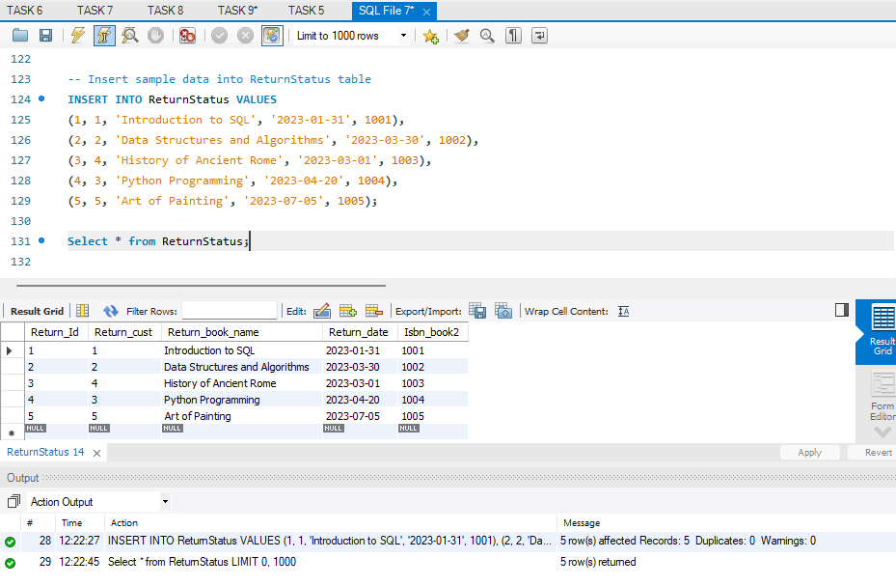

__________________________________________________________________________________

Display all the tables and Write the queries for the following :

1. Retrieve the book title, category, and rental price of all available books

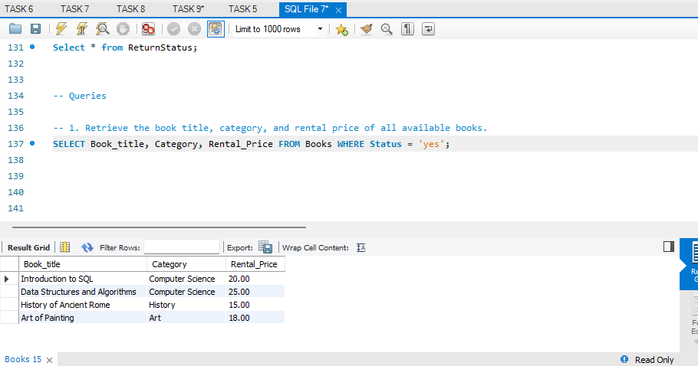

1. List the employee names and their respective salaries in descending order of salary.

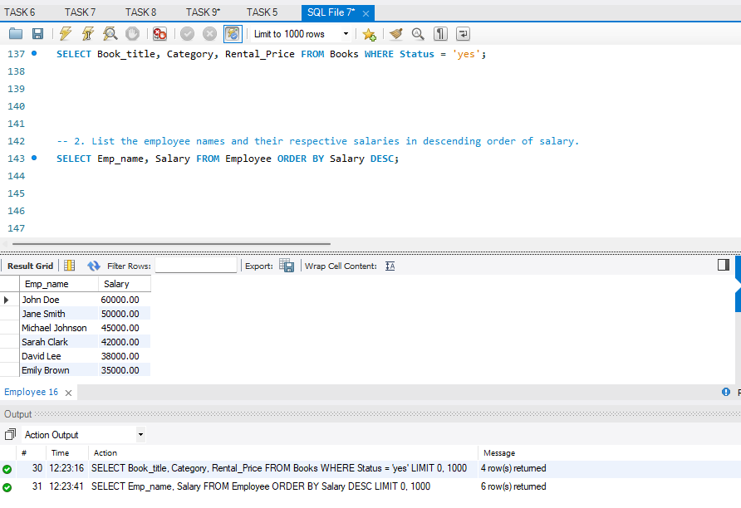

1. Retrieve the book titles and the corresponding customers who have issued those books.

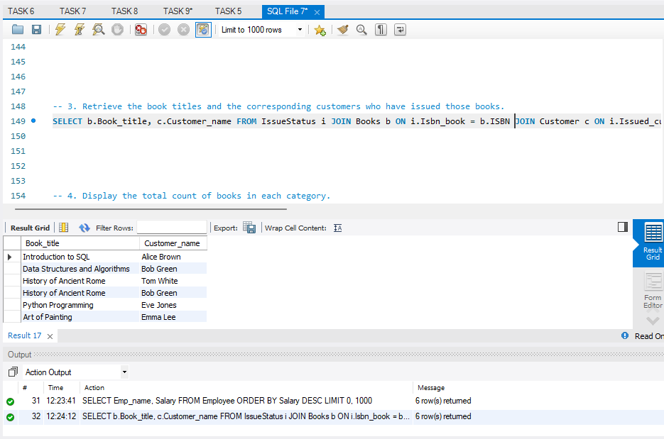

1. Display the total count of books in each category.

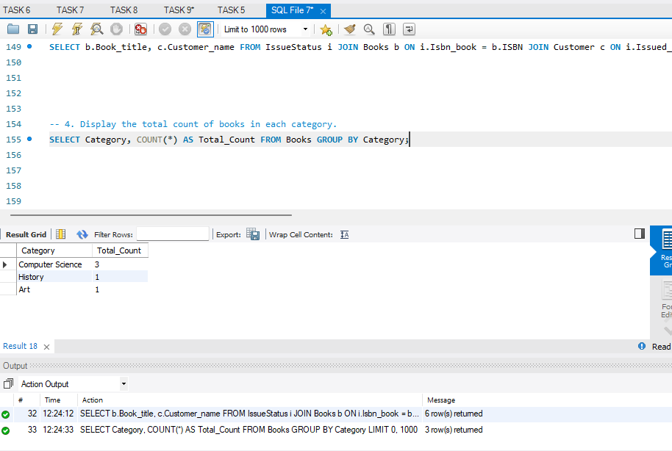

1. Retrieve the employee names and their positions for the employees whose salaries are above Rs.50,000.

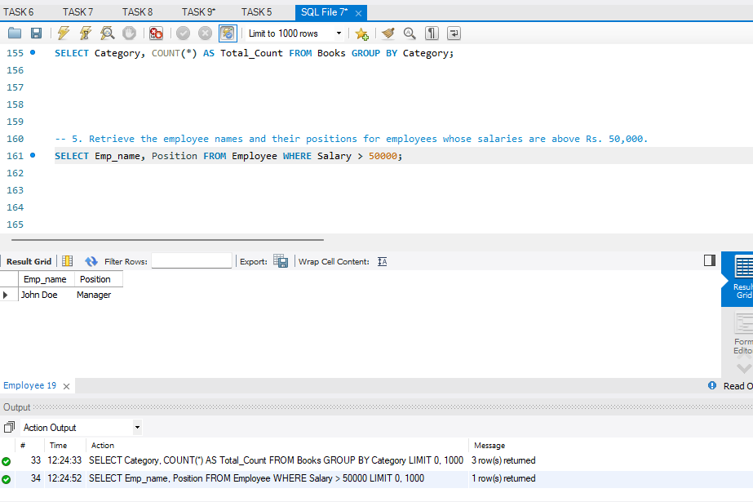

1. List the customer names who registered before 2022-01-01 and have not issued any books yet.

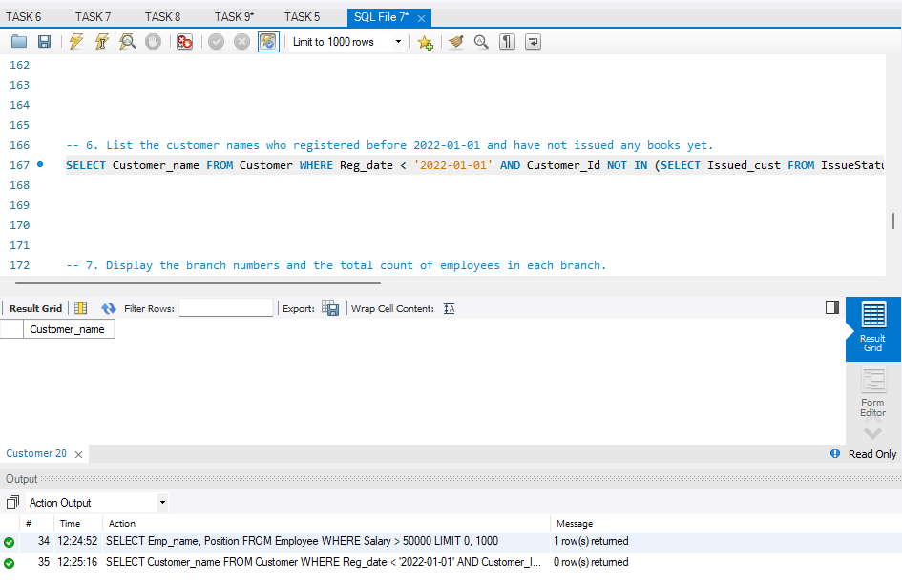

1. Display the branch numbers and the total count of employees in each branch.

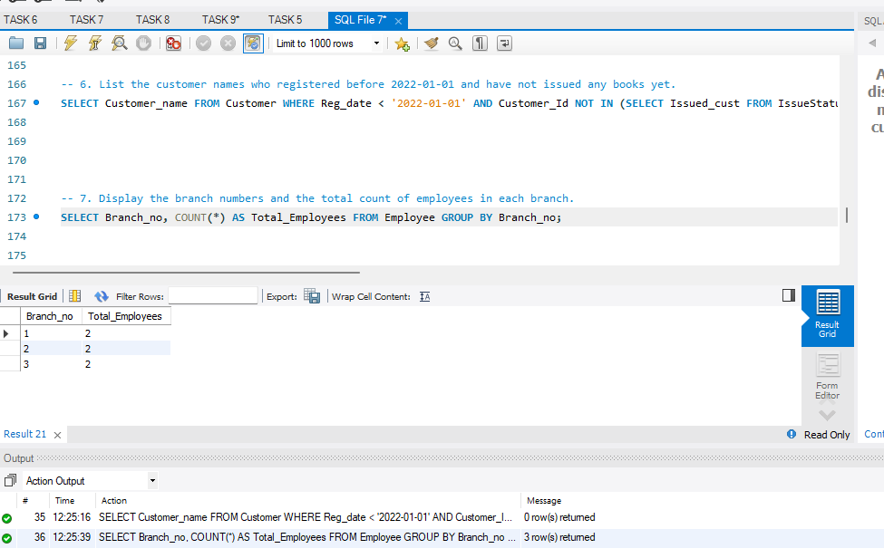

1. Display the names of customers who have issued books in the month of June 2023.

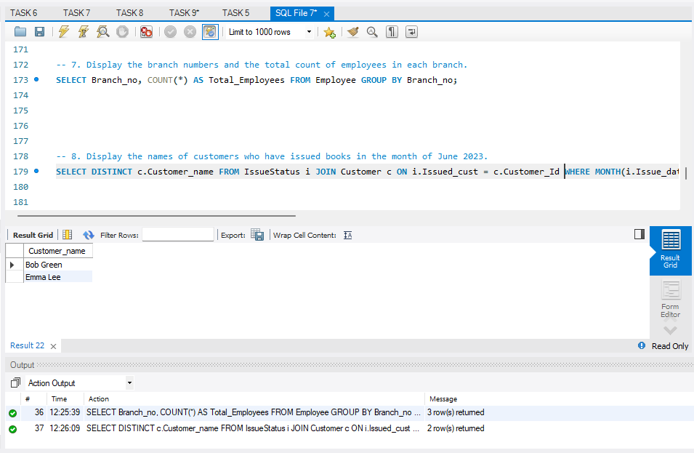

1. Retrieve book_title from book table containing history.

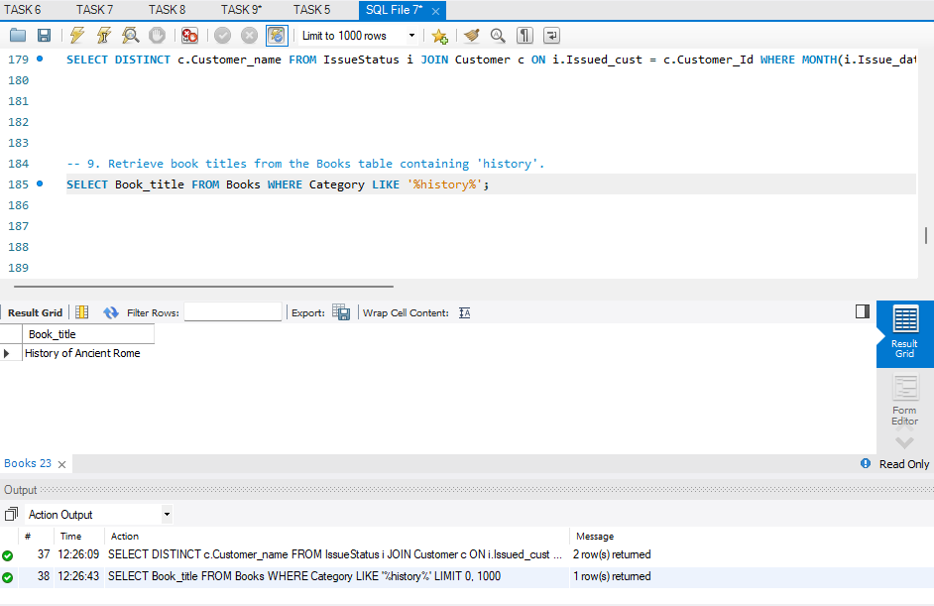

10.Retrieve the branch numbers along with the count of employees for branches having more than 5 employees

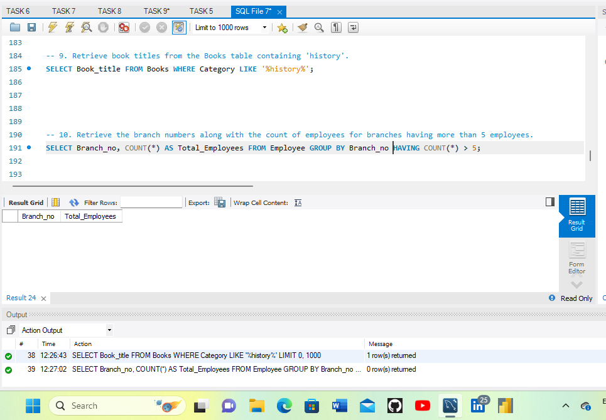

11.Retrieve the names of employees who manage branches and their respective branch addresses.

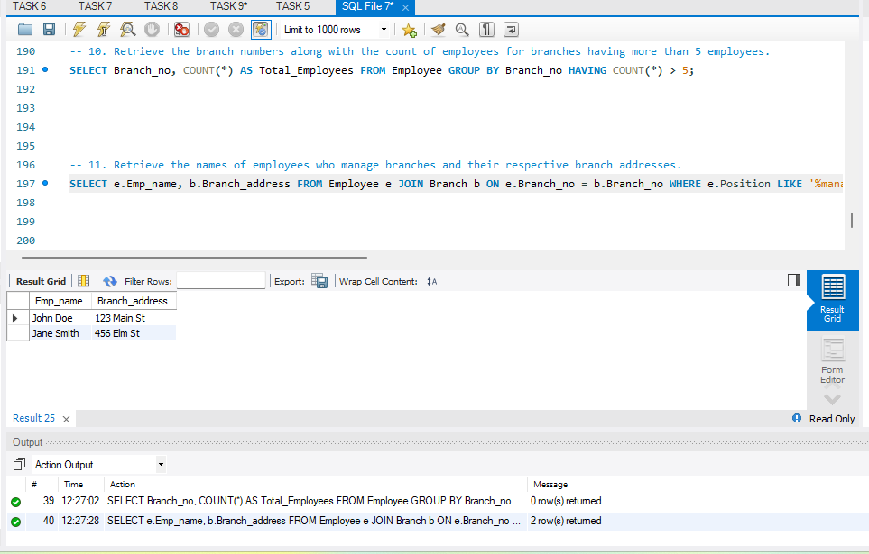

12. Display the names of customers who have issued books with a rental price higher than Rs. 25.



